Data Structure and Algorithms in Python

1. Objects

Python is an object-oriented language and classes form the basic for all data types.

* 1. Identifiers, Objects, and Assignment Statement

Establish an identifier, and then associates it with the object by assignment statement.

Each identifier is implicitly associated with the memory address of the object to which it refers.

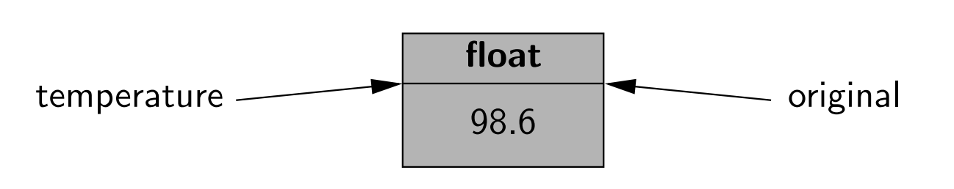

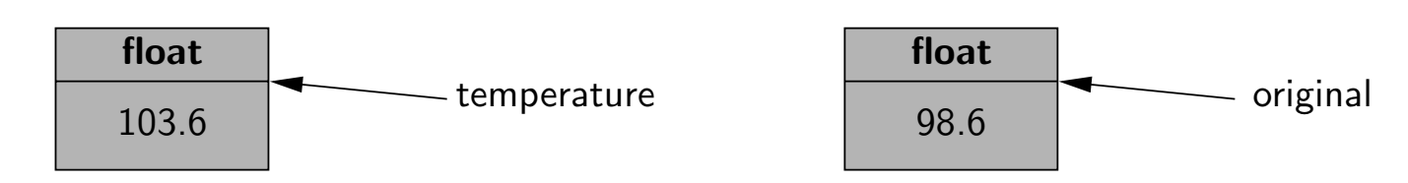

* 1. Creating and using objects
     1. instantiation

The process of creating a new instance of a class is known as instantiation. In general, the syntax for instantiating an object is to invoke the constructor of a class.

Many Python Built-in classes support literal form for designating new instances.

Another way to indirectly create a new instance of a class is to call a function that creates and returns an instance.

* + 1. Call the method

Some methods return information about the state of an object, but not change the state. These are known as accessors. Other methods, such as the sort method of the list class, do change the state of an object. These methods are known as mutators or update methods.

* + 1. Python built-in classes

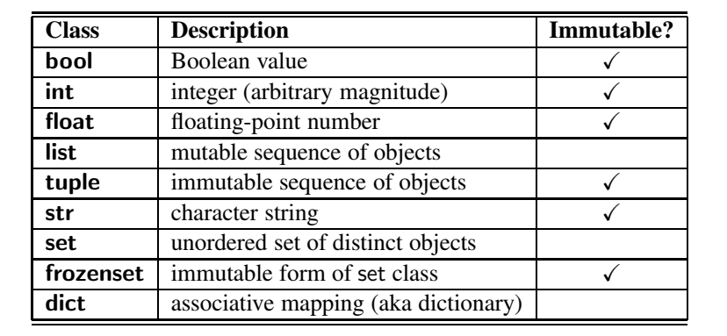

A class is immutable if each object of that class has a fixed value.

* + 1. Bool class

The bool class is used to manipulate logical values, and the only